A
PROJECT REPORT
ON
"SMART MOVIE BOOKING SYSTEM"
Real-Time Multi-Theater Movie Ticket Booking System with Smart Seat Conflict Handling
BACHELOR OF TECHNOLOGY
IN
COMPUTER SCIENCE AND ENGINEERING (CYBER SECURITY)
BY
GAravaind. - 24N81A6219
M. Naveen - 24N81A6223
K.Umesh- 25N85A6205
K.Dashrath - 24N81A6224
J.Tarun-24N81A6221
Under the Guidance of
Mrs. A. Sandhya Rani
Assistant Professor
Department of CSE (CYBER SECURITY)

DEPARTMENT OF COMPUTER SCIENCE AND ENGINEERING (CS)
SPHOORTHY ENGINEERING COLLEGE
Nadergul (Vill.), Near L.B. Nagar, Hyderabad, Telangana - 501510.
[2024-2028]

SPHOORTHY ENGINEERING COLLEGE
DEPARTMENT OF COMPUTER SCIENCE AND ENGINEERING (CS)
CERTIFICATE
This is to certify that this Real Time Research Project Report entitled "Smart Movie Booking System" is a Bonafide work carried out by G.Aravind (24N81A6219), M. Naveen (24N81A6223), K.Umesh (25N85A6205), K.Dashrath (24N81A62224),J.Tarun(24N81A6221), students of B.Tech Computer Science and Engineering (Cyber Security), Sphoorthy Engineering College, during the academic year 2024-2028.
The work presented in this report describes a real-time multi-theater movie ticket booking system with smart seat conflict handling, user authentication, booking management, notifications, and database-supported ticket generation.
The results embodied in this report have not been submitted to any other university or institute for the award of any degree or diploma.
Internal Guide Head of the Department
Mrs. A. Sandhya Rani
Assistant Professor
Department of CSE (CS), SPHN
ssss
DECLARATION
We the undersigned declare that the Real Time Research Project Report "Smart Movie Booking System" carried out at "Sphoorthy Engineering College" is original and is being submitted to the Department of Computer Science and Engineering (Cyber Security) as part of the B.Tech RTRP/PBL work.
We declare that the result embodied in this Real Time Research Project Report has not been submitted to any other University or Institute for the award of any Degree or Diploma.
Date:
Place: Hyderabad
G Aravaind. - 24N81A6219
M. Naveen - 24N81A6223
K .Umesh- 25N85A6205
K. Dashrath - 24N81A6224
J.Tarun-24N81A6221

ACKNOWLEDGEMENT
We sincerely thank our Project Guide Mrs. A. Sandhya Rani, Assistant Professor, Department of Computer Science & Engineering (Cyber Security), Sphoorthy Engineering College, for her valuable guidance, encouragement, and continuous support during the development of this project.
We express our sincere thanks to the Head of the Department, Department of Computer Science & Engineering (CS), Sphoorthy Engineering College, Nadergul, for providing the required academic support and facilities.
We deem it a great privilege to express our profound gratitude and sincere thanks to the management, Principal, faculty members, and non-teaching staff of Sphoorthy Engineering College for their encouragement throughout this work.
We also thank our classmates, friends, and family members for their cooperation and motivation during the completion of this Smart Movie Booking System project.
BATCH: 2024 - 2028

ABSTRACT
Smart Movie Booking System is a web-based real-time movie ticket booking application designed to simplify movie discovery, show selection, seat booking, ticket generation, and theatre-side validation. The system supports multiple theatres, screens, shows, seat categories, booking history, notifications, and administrative monitoring in a single integrated platform.
The main objective of this project is to overcome the problem of seat conflicts that occur when multiple users try to select the same seat at the same time. The system uses real-time seat locking through Socket.io so that a seat selected by one user is instantly shown as locked to all other connected users. This prevents double booking and improves the reliability of the booking process.
The platform includes OTP-based user authentication, role-based access for users, admins, and theatre owners, a movie management workflow, a live seat map, QR-based ticket generation, booking records, notification support, and a MySQL database for persistent storage. The application is implemented using Node.js, Express.js, EJS, JavaScript, MySQL, Socket.io, Nodemailer, and QR code utilities.
Smart seat conflict handling is the central feature of this project. Before a booking is confirmed, seats are temporarily locked for the active user, released automatically after a fixed timeout if the user does not complete the process, and finally marked as booked after successful ticket creation. This approach makes the system suitable for high-demand movie shows where many users may book seats concurrently.
Overall, the Smart Movie Booking System provides a practical, scalable, and user-friendly solution for modern theatres and online ticket booking platforms by combining real-time updates, secure authentication, reliable database handling, and an efficient ticket validation process.

INDEX
Contents | Page No.
Abstract | I
Index | II
List of Figures | III
Chapter 1 - Introduction | 1
Chapter 2 - Literature Survey | 6
Chapter 3 - System Design | 10
Chapter 4 - Implementation | 18
Chapter 5 - Evaluation | 23
Chapter 6 - Conclusion and Future Enhancement | 31
References | 34
Appendix and Sample Code | 35

LIST OF FIGURES
Figure No. | Figure Name | Page No.
3.1 | System Architecture Diagram | 14
3.2 | System Flow Diagram | 15
3.3 | Use Case Diagram | 16
3.4 | Class Diagram | 17
3.5 | Sequence Diagram | 17
3.6 | Activity Diagram | 18
5.1 | Home/Landing Page | 23
5.2 | Movie Listing Page | 23
5.3 | Movie Details and Show Selection | 24
5.4 | Real-Time Seat Selection Page | 24
5.5 | Smart Seat Conflict Handling | 25
5.6 | Ticket and QR Validation | 25
5.7 | User Dashboard/Booking History | 26
5.8 | Admin Dashboard | 26
5.9 | Theatre Owner Dashboard/Scanner | 27

CHAPTER-1
INTRODUCTION
PROBLEM STATEMENT
Traditional and semi-digital movie ticket booking systems often face issues such as delayed seat status updates, double booking conflicts, manual theatre coordination, limited booking transparency, and poor synchronization between users who are selecting seats for the same show. When many users try to book tickets for a popular movie at the same time, the absence of instant seat locking may allow two or more users to select the same seat before the booking is finalized.
The Smart Movie Booking System is developed to solve this problem by providing a real-time multi-theater booking platform with smart seat conflict handling. The system instantly locks selected seats, synchronizes seat status across all active users, and stores confirmed bookings in a structured database.
OBJECTIVE
1. To develop a web-based movie ticket booking system for users, admins, and theatre owners.
2. To provide real-time seat availability updates using Socket.io.
3. To prevent double booking through smart temporary seat locking and timeout-based release.
4. To support multiple theatres, screens, movies, show timings, and seat categories.
5. To generate digital tickets with QR code validation for theatre entry.
6. To maintain booking history, notifications, and administrative reports.
7. To store users, movies, theatres, shows, seats, bookings, tickets, reviews, and notifications in MySQL.
EXISTING SYSTEM
In many existing booking systems, seat availability is refreshed only after a booking is completed or after the page is manually reloaded. During peak booking periods, this creates uncertainty because users may select seats that have already been selected by others. Some theatres still depend on manual counters or separate systems for theatre-side validation, which increases operational delay.
Drawbacks:
• Seat status is not always updated in real time.
• Double booking conflicts may occur during high demand.
• Users may discover seat unavailability only at the final confirmation stage.
• Admin and theatre owner workflows are often separated from the customer booking flow.
• Booking history, notifications, and ticket validation may not be integrated.
• Manual ticket checking is time-consuming and prone to errors.
PROPOSED SYSTEM
The proposed Smart Movie Booking System is a complete online ticket booking platform that enables users to browse movies, select theatres and show timings, view a live seat map, lock seats instantly, and generate tickets. The system provides admin and theatre dashboards for movie, show, booking, occupancy, and ticket validation management.
Key Features of Proposed System
• OTP-based user authentication and role-based access control.
• Movie browsing with details, ratings, reviews, theatres, and show timings.
• Real-time seat locking and unlocking using Socket.io.
• Smart conflict handling to avoid double bookings.
• Multi-theater and multi-screen show management.
• Booking history and QR-based digital ticket generation.
• Admin dashboard for users, bookings, movies, reviews, and support monitoring.
• Theatre owner dashboard with show creation, scanner validation, and occupancy statistics.
• Notification support for booking reminders and user alerts.
Working of the System
1. User logs in through OTP authentication.
2. User selects a movie, theatre, date, and show time.
3. System displays the real-time seat layout for the selected show.
4. When the user selects a seat, the seat is locked for that user and broadcast to other users.
5. If another user tries to lock the same seat, the system rejects the request and displays a conflict message.
6. After confirmation, the booking is stored and selected seats are marked as booked.
7. A QR ticket is generated and can be validated by the theatre owner.
SCOPE
The scope of this project includes the design and implementation of a real-time online ticket booking system for theatres and multiplexes. It covers user registration/login, movie listing, show selection, live seat selection, booking confirmation, QR ticket generation, admin operations, theatre operations, notifications, and database management.
Applications:
• Multiplex theatre ticket booking systems.
• Online movie booking web applications.
• College event and auditorium seat reservation systems.
• Festival, seminar, and public screening ticket platforms.
• Theatre-side ticket validation and occupancy monitoring systems.
Future Scope:
• Payment gateway integration for complete online payment workflow.
• AI-based seat suggestions based on user preference and group size.
• Dynamic pricing based on demand, time, and theatre occupancy.
• Mobile application support for Android and iOS.
• Advanced analytics for movie demand forecasting and theatre revenue reports.
• Push notification reminders for upcoming shows and ticket status.
SOFTWARE AND HARDWARE REQUIREMENTS
Software Requirements
• Operating System: Windows 10 / Windows 11
• Frontend: HTML, CSS, Bootstrap, JavaScript, EJS
• Backend: Node.js and Express.js
• Database: MySQL
• Real-Time Communication: Socket.io
• Authentication and Utilities: JSON Web Token, Nodemailer OTP, QRCode
• IDE: Visual Studio Code
Hardware Requirements
• RAM: 4 GB minimum, 8 GB recommended
• Storage: 50 GB free disk space minimum
• Processor: Intel Core i3 / Core i5 or equivalent AMD processor
• System Type: 64-bit operating system
• Network: Stable internet or local network for real-time testing

CHAPTER-2
LITERATURE SURVEY
2.1 SURVEY OF MAJOR AREA RELEVANT TO PROJECT
Online Ticket Booking Systems:
Online ticket booking systems allow users to search shows, select seats, confirm bookings, and receive digital tickets. They reduce manual counter workload and improve customer convenience.
Real-Time Web Applications:
Real-time web applications use event-driven communication to update connected clients instantly. In this project, Socket.io is used to synchronize seat locks and prevent stale seat availability displays.
Database Transaction Management:
A booking system requires reliable database operations to maintain user records, movies, theatres, shows, seats, bookings, and tickets. Constraints such as unique show-seat combinations and booking-seat mappings help maintain data integrity.
Authentication and Role-Based Access:
Secure access is required because users, admins, and theatre owners perform different operations. OTP login and role-based middleware restrict access to appropriate dashboards and booking functions.
QR-Based Ticket Validation:
QR ticket systems provide fast digital validation at theatre entry. The generated QR code links the booking identity with show, seat, and validation status, reducing manual checking errors.
Notification and Reminder Systems:
Notification systems improve communication by alerting users about bookings, show reminders, support updates, and other events related to the ticket lifecycle.
2.2 TECHNIQUES AND ALGORITHMS
OTP Authentication
A six-digit OTP is generated and sent to the user email. The OTP has limited validity and is verified before creating a login session.
Socket-Based Seat Locking
When a user selects a seat, the server checks the current database status and active in-memory lock state. If the seat is available, it is locked for the user and the update is broadcast to all clients in the show room.
Timeout-Based Auto Unlock
Temporary locks expire after a fixed duration if the user does not confirm the booking. This prevents abandoned seat selections from blocking other users permanently.
Unique Seat Constraints
The database stores each seat against a show with a unique show-seat combination. Booking-seat relations ensure that confirmed seats are traceable to a valid booking.
QR Ticket Generation
After successful booking, a unique booking code is converted into a QR ticket, which can be scanned by theatre-side validation tools.
Role-Based Routing
Middleware checks the logged-in user's role and allows access only to permitted user, admin, or theatre owner pages.
2.3 APPLICATIONS
• Real-time movie ticket booking for multiplex theatres.
• Seat reservation systems for seminar halls and auditoriums.
• Event ticketing platforms for college events and public screenings.
• Theatre-side occupancy tracking and ticket validation.
• Admin monitoring systems for bookings, users, shows, and reviews.
• Digital ticket systems using QR code validation.

CHAPTER-3
SYSTEM DESIGN
System design describes the structure, data flow, modules, and user interactions of the Smart Movie Booking System. The design focuses on real-time booking accuracy, conflict-free seat selection, multi-theater support, and secure role-based operations.
Modules of System Design
• User Authentication Module
• Movie and Show Management Module
• Real-Time Seat Booking Module
• Smart Seat Conflict Handling Module
• Booking and Ticket Generation Module
• Admin Dashboard Module
• Theatre Owner and QR Scanner Module
• Notification and Support Module
• Database Management Module
3.1 SYSTEM ARCHITECTURE
The system follows a layered web application architecture. The presentation layer contains EJS views, HTML, CSS, Bootstrap, and client-side JavaScript. The application layer is built with Node.js and Express.js routes, controllers, middleware, and services. The real-time layer uses Socket.io to manage show rooms, seat lock events, and live updates. The data layer uses MySQL tables for users, movies, theatres, screens, shows, seats, bookings, booking seats, tickets, reviews, notifications, and reminders.
Smart seat conflict handling is implemented between the real-time layer and the data layer. Every seat lock request is checked against the confirmed seat status in the database and the current lock state maintained by the seat lock manager. If the seat is already booked or locked by another user, the request is rejected. If it is available, a temporary lock is created, broadcast to all users viewing the same show, and automatically released after the timeout unless booking is completed.
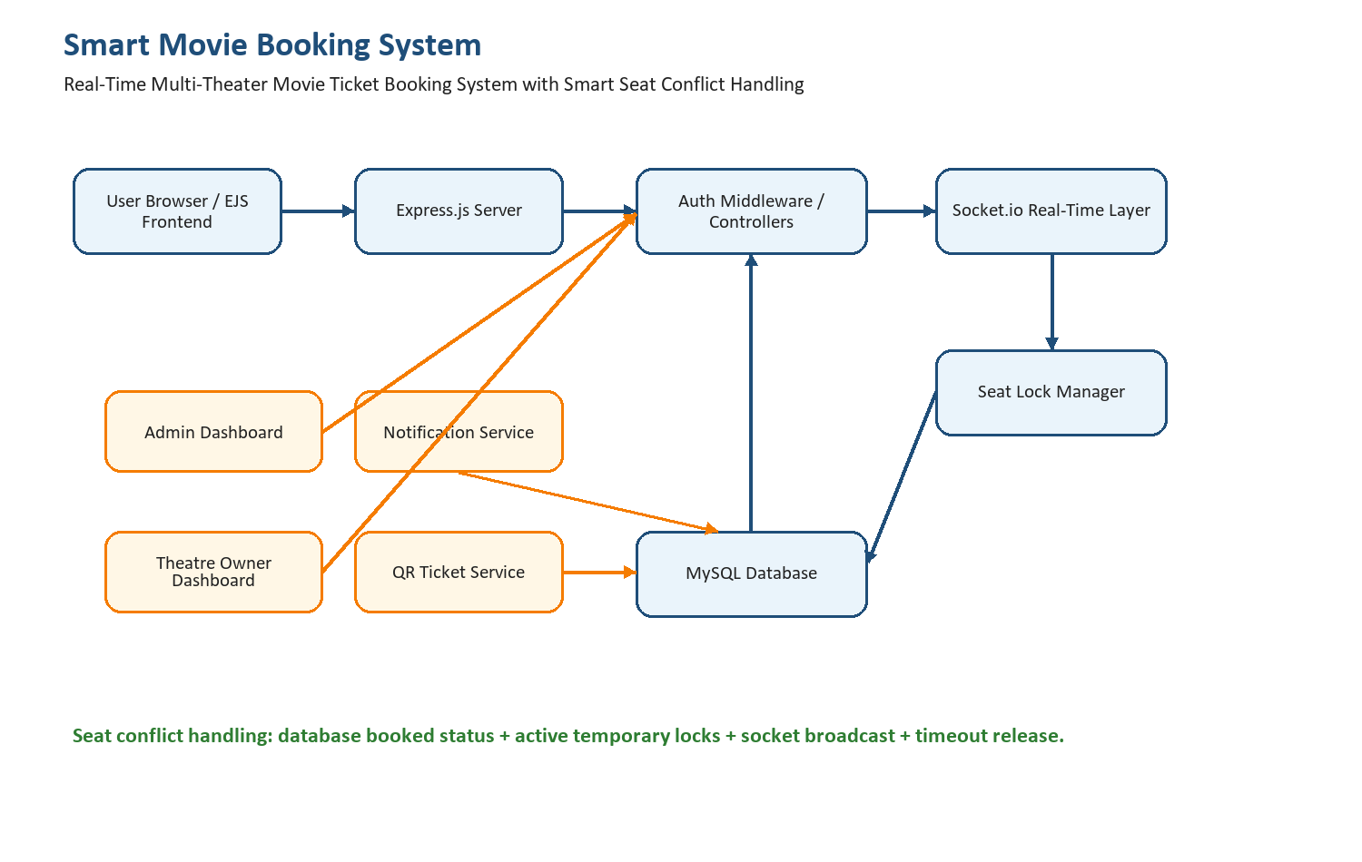
Figure 3.1: System Architecture Diagram
3.2 SYSTEM FLOW
The booking flow begins when a user logs in, selects a movie, chooses a theatre and show timing, and opens the seat selection page. The client joins a Socket.io room for the selected show and receives the current lock state. Seat selections are then synchronized in real time until the booking is confirmed or cancelled.
1. User opens the movie listing page and selects a movie.
2. System displays theatres, dates, and show timings.
3. User logs in using OTP if not already authenticated.
4. User enters the seat selection page for a selected show.
5. Client joins the real-time show room using Socket.io.
6. User selects seats; server verifies availability and creates temporary locks.
7. Other users immediately see the selected seats as locked.
8. User confirms booking; database creates booking and booking seat records.
9. Selected seats are updated as booked and a QR ticket is generated.
10. Theatre owner validates the ticket using QR scanner or booking code.
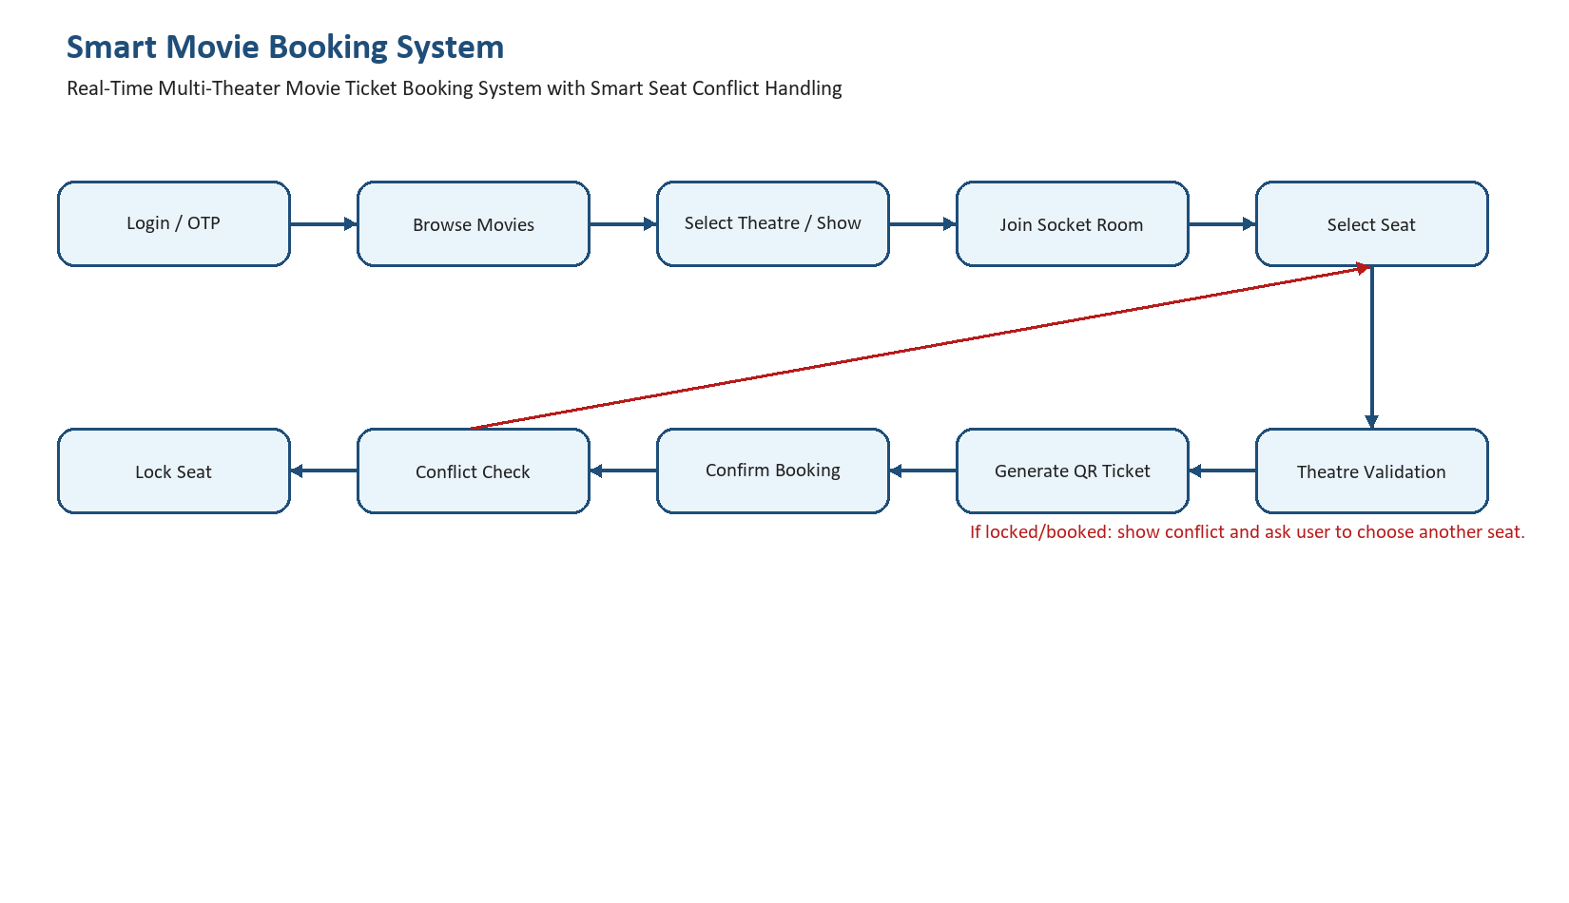
Figure 3.2: System Flow Diagram
3.3 MODULE DESCRIPTION
User Authentication Module
Handles OTP login, token creation, session validation, and role identification for users, admins, and theatre owners.
Movie Management Module
Displays movie details such as title, genre, language, duration, certificate, posters, ratings, reviews, theatres, and show schedules.
Real-Time Seat Booking Module
Displays the seat map, seat categories, seat prices, available/booked/locked states, selected seat summary, and ticket confirmation controls.
Smart Seat Conflict Handling Module
Prevents two users from booking the same seat by combining database checks, in-memory lock ownership, socket rooms, lock rejection events, and timeout-based auto unlock.
Booking History Module
Maintains all user bookings with movie, theatre, date, time, seats, amount, ticket, and booking code details.
Payment Workflow Module
The current project simulates the booking confirmation workflow and stores the total amount. It is structured so a payment gateway such as Razorpay can be integrated before final ticket confirmation.
Admin Dashboard Module
Allows admins to monitor users, bookings, movies, reviews, support conversations, and overall platform activity.
Theatre Owner Module
Allows theatre owners to create screens and shows, view occupancy, validate QR tickets, and monitor scanned tickets.
Notification Module
Stores and displays notifications related to bookings, reminders, and user support updates.
Database Module
Manages relational tables, constraints, indexes, and queries required for reliable booking and ticket lifecycle management.
3.4 UML DIAGRAM
The following UML diagrams are represented as placeholders in this report. They can be replaced with final drawn diagrams during submission without changing the report structure.
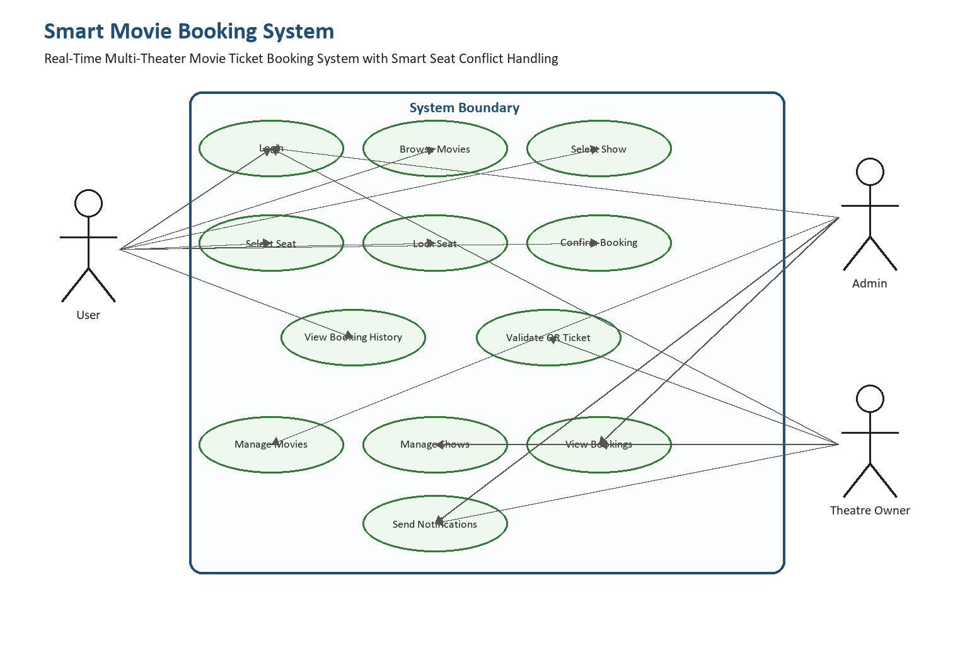
Figure 3.3: Use Case Diagram
Actors: User, Admin, Theatre Owner. Use cases: Login, Browse Movies, Select Show, Lock Seat, Confirm Booking, View Booking History, Manage Movies, Manage Shows, Validate Ticket, Send Notifications.
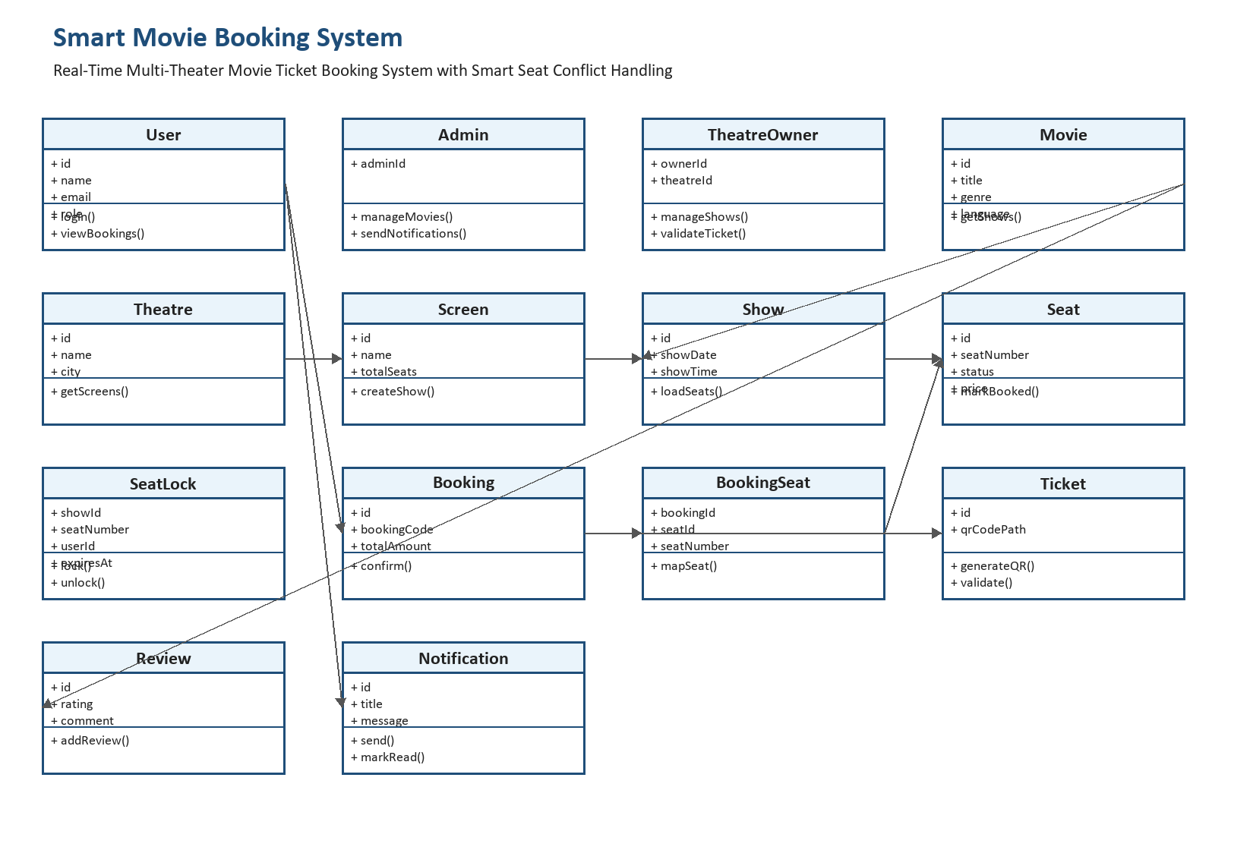
Figure 3.4: Class Diagram
Classes: User, Movie, Theatre, Screen, Show, Seat, Booking, BookingSeat, Ticket, Notification, Review, SeatLockManager.
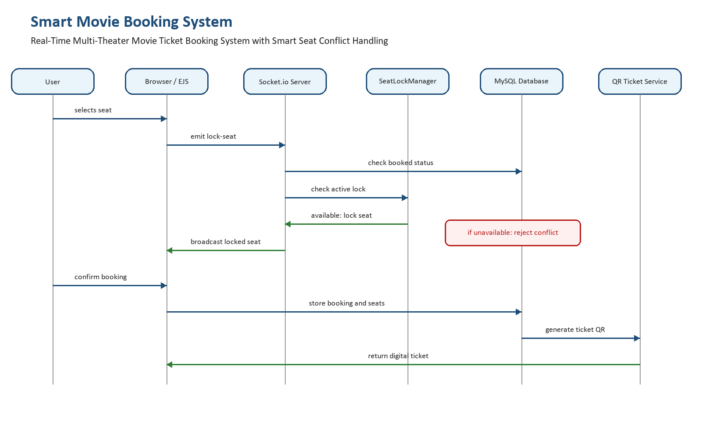
Figure 3.5: Sequence Diagram
Sequence: User selects seat, Browser emits lock-seat, Server checks database and lock manager, SeatLockManager confirms or rejects, Server broadcasts lock state, User confirms booking, Database updates seat status.
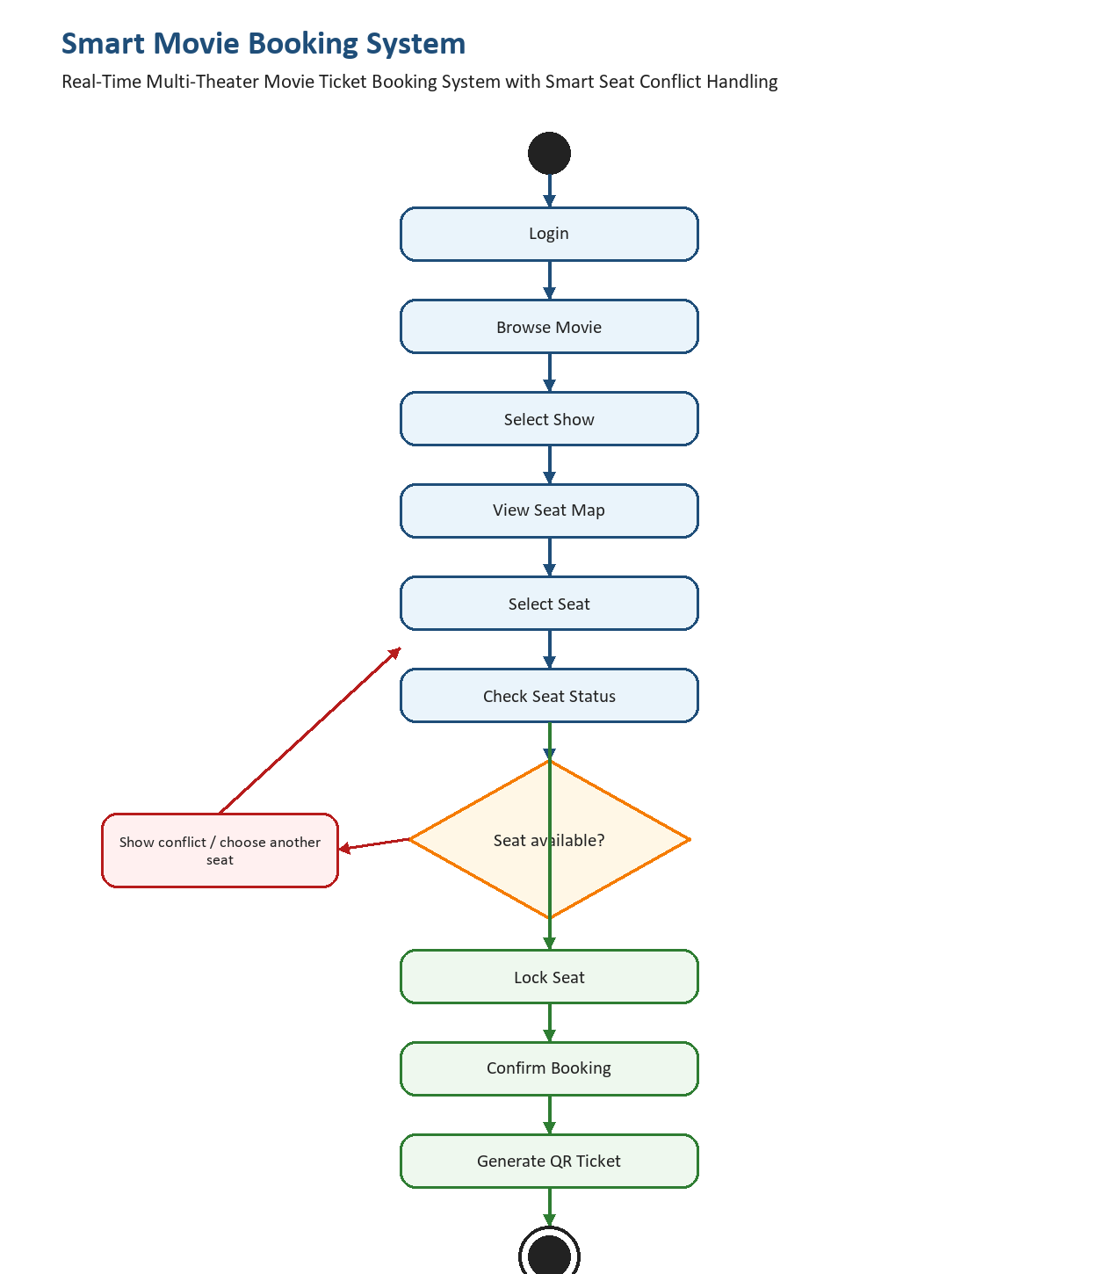
Figure 3.6: Activity Diagram
Activity: Login -> Select Movie -> Select Show -> Join Seat Room -> Lock Seats -> Confirm Booking -> Generate Ticket -> Validate Ticket.

CHAPTER-4
IMPLEMENTATION
4.1 ENVIRONMENT SETUP
The Smart Movie Booking System is implemented as a Node.js web application. Express.js manages routing and server-side rendering, EJS is used for dynamic views, MySQL stores the relational data, and Socket.io provides real-time seat state synchronization.
Component | Technology Used
Frontend | HTML, CSS, Bootstrap, JavaScript, EJS
Backend | Node.js, Express.js
Database | MySQL
Real-Time Engine | Socket.io
Authentication | OTP using Nodemailer and JWT/session cookies
Ticketing | QR code generation and theatre-side validation
Development Tool | Visual Studio Code

4.2 IMPLEMENTATION OF MODULES
User Module
Users can log in through OTP, browse movies, filter shows, select seats, confirm bookings, view booking history, and access generated QR tickets.
Movie and Show Module
Movies, theatres, screens, and shows are loaded from the database. Each show has a date, time, screen, theatre, and associated seat layout.
Seat Booking Module
The seat page renders 300 seats per show with categories such as GOLD and SILVER. Users can zoom or move the seat map and select available seats.
Smart Seat Conflict Handling
When a seat is clicked, the browser sends a lock-seat event to the server. The server verifies that the user is authenticated, checks whether the seat is already booked in MySQL, checks whether another socket currently holds the temporary lock, and then either confirms the lock or rejects it with an error message. Confirmed locks are broadcast to everyone in the same show room. Locks are released when the user unlocks the seat, disconnects, or the timeout expires.
Booking and Ticket Module
After seat confirmation, booking records are created, selected seats are marked as booked, booking seats are linked to the booking, and a QR ticket is generated for validation.
Admin Module
Admin users can monitor platform records such as movies, bookings, users, reviews, support messages, and overall booking activity.
Theatre Owner Module
Theatre owners can manage shows for their theatre, view booking and occupancy statistics, and validate tickets using QR scanning or booking code checks.
Notification Module
Notifications are stored in the database and delivered to users for booking-related alerts, reminders, and support messages.
Database Module
The database schema includes users, movies, theatres, screens, shows, seats, bookings, booking_seats, tickets, reviews, conversations, messages, notifications, push subscriptions, and booking reminders.
4.3 INTEGRATION AND DEVELOPMENT
The system integrates Express routes, controllers, EJS pages, Socket.io events, and MySQL queries. Routes manage normal web navigation, controllers handle business logic, middleware verifies authentication and role permissions, and services handle notifications and ticket-related operations.
The real-time integration is implemented by joining each connected client to a room based on the selected show ID. This isolates seat updates to the correct show. When one user locks or unlocks a seat, the event is sent only to users viewing the same show, ensuring fast and relevant updates.
Payment Workflow Explanation
The present implementation records the booking amount and completes ticket generation after seat confirmation. The application dependencies include Razorpay support, and the workflow can be extended by placing payment order creation and payment verification between seat lock confirmation and final booking creation. This ensures that seats remain temporarily locked during payment and are either booked after payment success or released after timeout/payment failure.

CHAPTER-5
EVALUATION
5.1 MODULES
• Login and OTP Verification Module
• Movie Listing and Movie Detail Module
• Theatre and Show Selection Module
• Real-Time Seat Selection Module
• Smart Seat Conflict Handling Module
• Booking Confirmation and QR Ticket Module
• User Booking History Module
• Admin Dashboard Module
• Theatre Owner Dashboard and Scanner Module
• Notification and Support Module
5.2 EVALUATION METRICS
Metric | Description
Functional Accuracy | Checks whether login, movie browsing, seat selection, booking, and ticket generation work correctly.
Seat Conflict Prevention | Checks whether the system prevents two users from locking or booking the same seat.
Real-Time Response | Measures whether seat lock and unlock updates appear instantly for other users.
Database Integrity | Checks whether bookings, seats, tickets, and users are stored consistently.
Usability | Checks whether users can complete booking with simple navigation and clear seat status indicators.
Security | Checks OTP login, role-based access, and prevention of unauthorized dashboard access.
Scalability | Checks whether the design can support multiple theatres, shows, and concurrent users.

5.3 TEST CASES
Test Case | Module | Input/Action | Expected Result | Status
TC-01 | OTP Login | Enter valid email and OTP | User dashboard opens | Pass
TC-02 | Invalid OTP | Enter wrong OTP | System shows validation error | Pass
TC-03 | Movie Browse | Open movie listing page | Movies are displayed with details | Pass
TC-04 | Show Selection | Select movie and show timing | Seat layout page opens | Pass
TC-05 | Seat Lock | User selects available seat | Seat becomes locked for that user | Pass
TC-06 | Seat Conflict | Second user selects same locked seat | Lock request is rejected | Pass
TC-07 | Auto Unlock | User leaves selected seat idle | Seat releases after timeout | Pass
TC-08 | Booking Confirmation | Confirm selected seats | Booking and QR ticket are generated | Pass
TC-09 | Booking History | Open user dashboard | Past/upcoming bookings are listed | Pass
TC-10 | Admin Access | Admin opens dashboard | Admin data and controls are shown | Pass
TC-11 | Theatre Scanner | Validate QR ticket | Ticket status is returned as valid | Pass
TC-12 | Notification | Trigger booking reminder/support message | Notification is stored/displayed | Pass

Requirement Analysis
The system requirements were analyzed from the need for a real-time movie ticket booking platform that prevents double booking and supports multiple theatre operations.
Test Planning
Testing was planned around login, booking, seat conflict handling, QR validation, admin workflow, theatre workflow, and database consistency.
Test Case Design
Test cases were designed to cover normal user actions, invalid inputs, concurrent seat selection, timeout release, and role-based access control.
Test Environment Setup
The test environment includes Node.js, Express.js, MySQL, Socket.io, browser clients, seeded movie and theatre data, and demo user/admin/theatre accounts.
Bug Reporting
Any issue identified during testing is recorded with module name, input condition, expected output, actual output, and correction status.
Bug Fixing & Retesting
After fixing an issue, the same test case is executed again to confirm that the expected behavior is achieved without affecting other modules.
Final Testing
Final testing confirms that users can complete booking, admins can monitor data, theatre owners can validate tickets, and seat conflicts are handled reliably.
Test Closure
Testing is closed after all major modules produce the expected results and no critical booking or seat conflict defects remain.
5.4 RESULTS
Results Obtained
• The system successfully displays movie and theatre information to users.
• Users can log in with OTP and access protected booking features.
• The real-time seat map shows available, locked, booked, and user-selected seats.
• Socket.io synchronization prevents two users from locking the same seat at the same time.
• Timeout-based unlocking releases abandoned seats automatically.
• Confirmed bookings are stored in the database with seat and ticket details.
• QR tickets are generated and can be validated from the theatre dashboard.
• Admin and theatre dashboards provide monitoring and operational support.
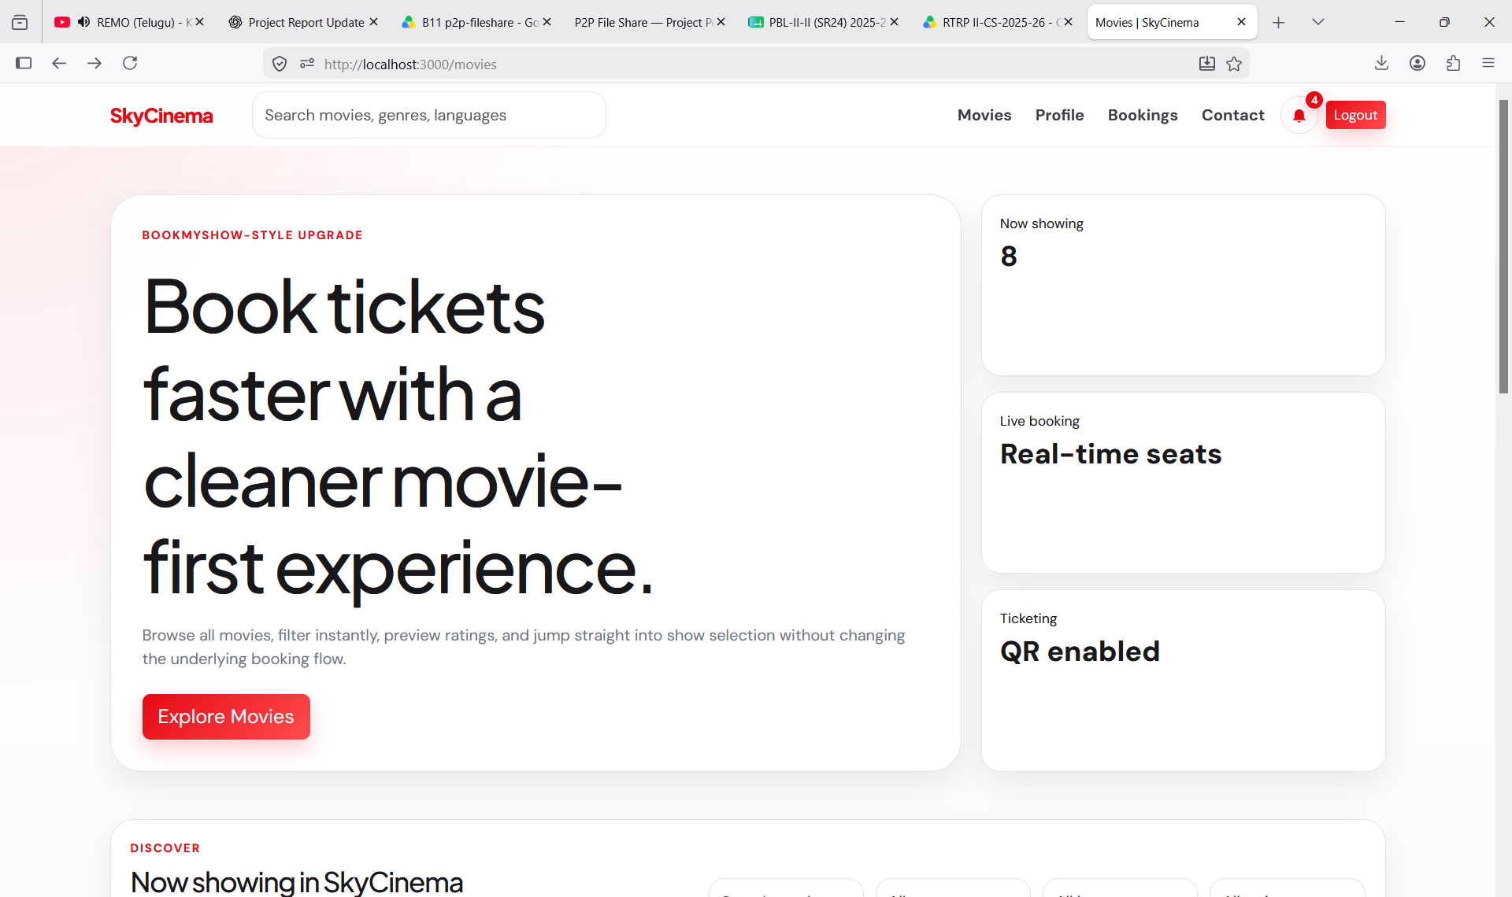
Figure 5.1: Home/Landing Page
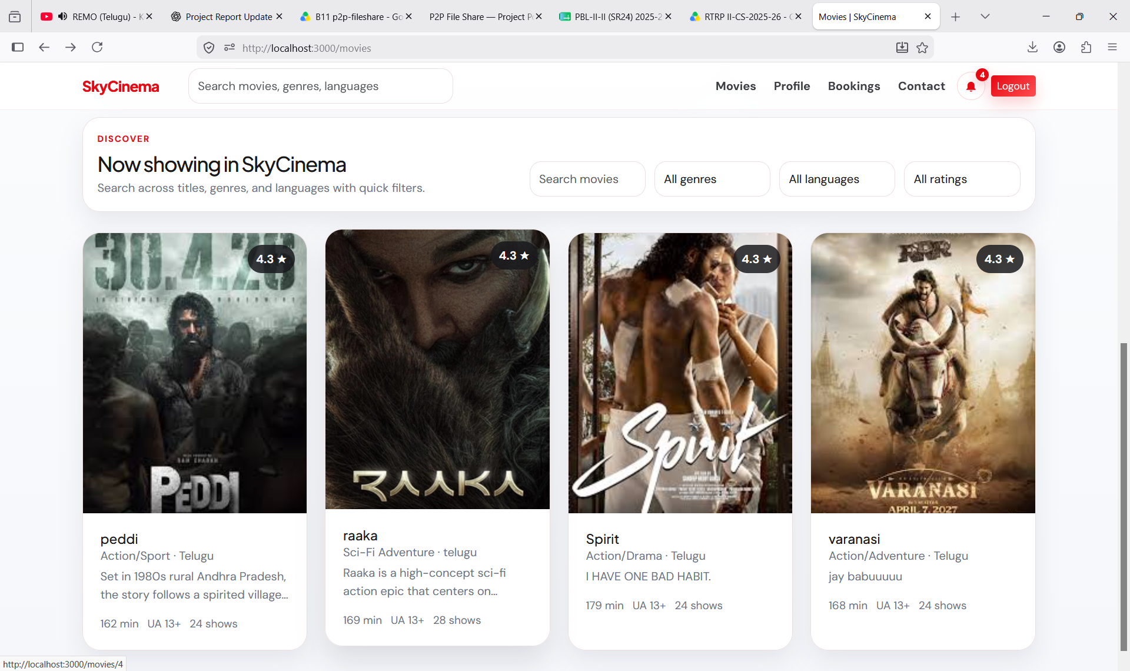
Figure 5.2: Movie Listing Page
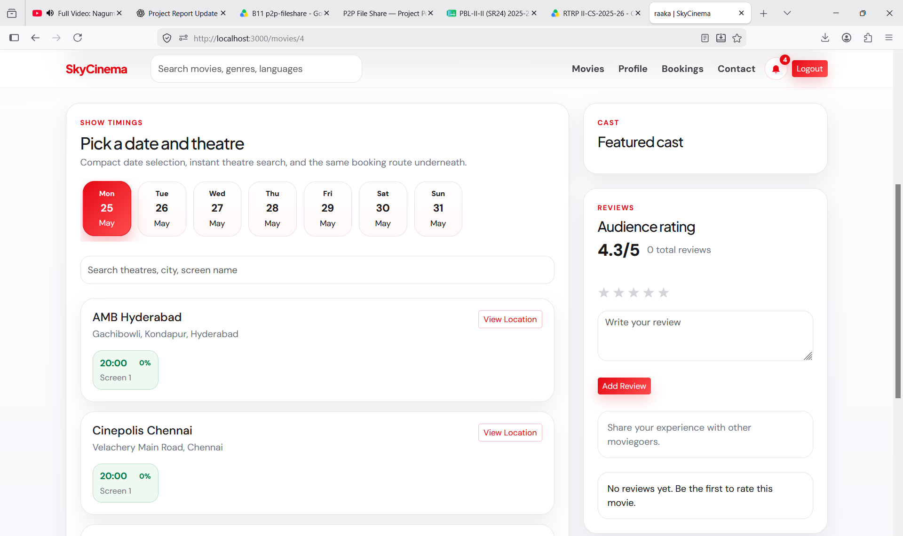
Figure 5.3: Movie Details and Show Selection
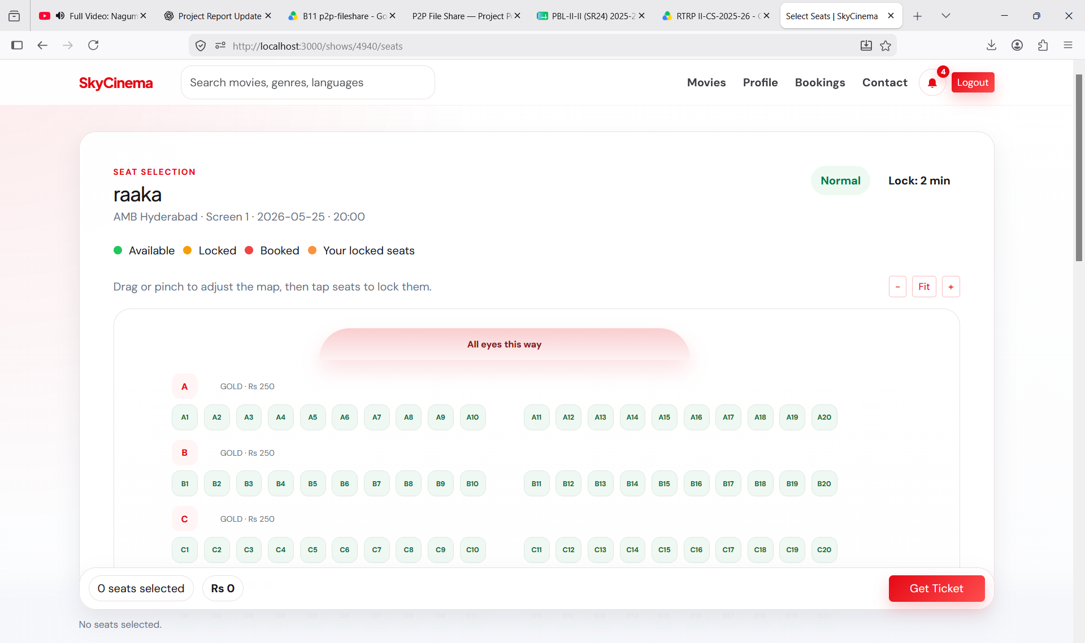
Figure 5.4: Real-Time Seat Selection Page
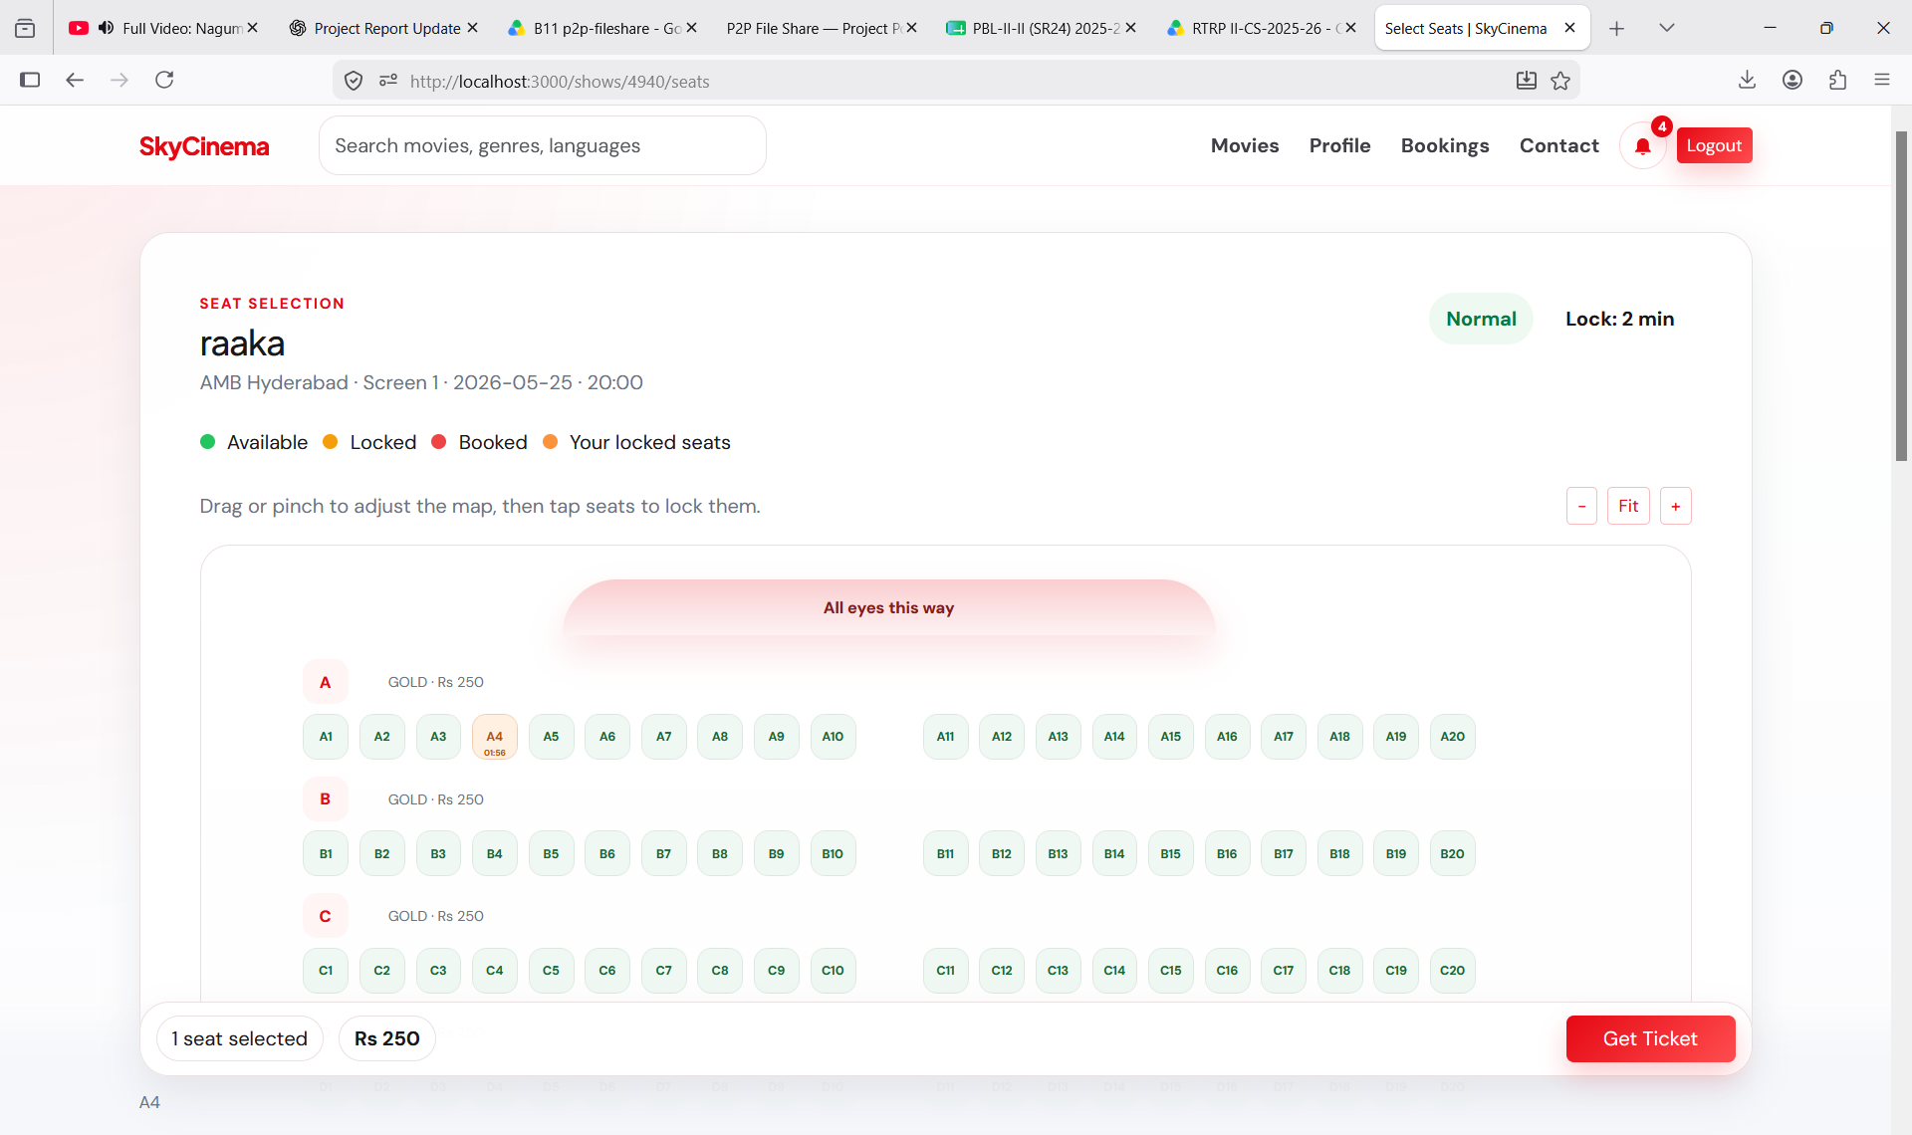
Figure 5.5: Smart Seat Conflict Handling
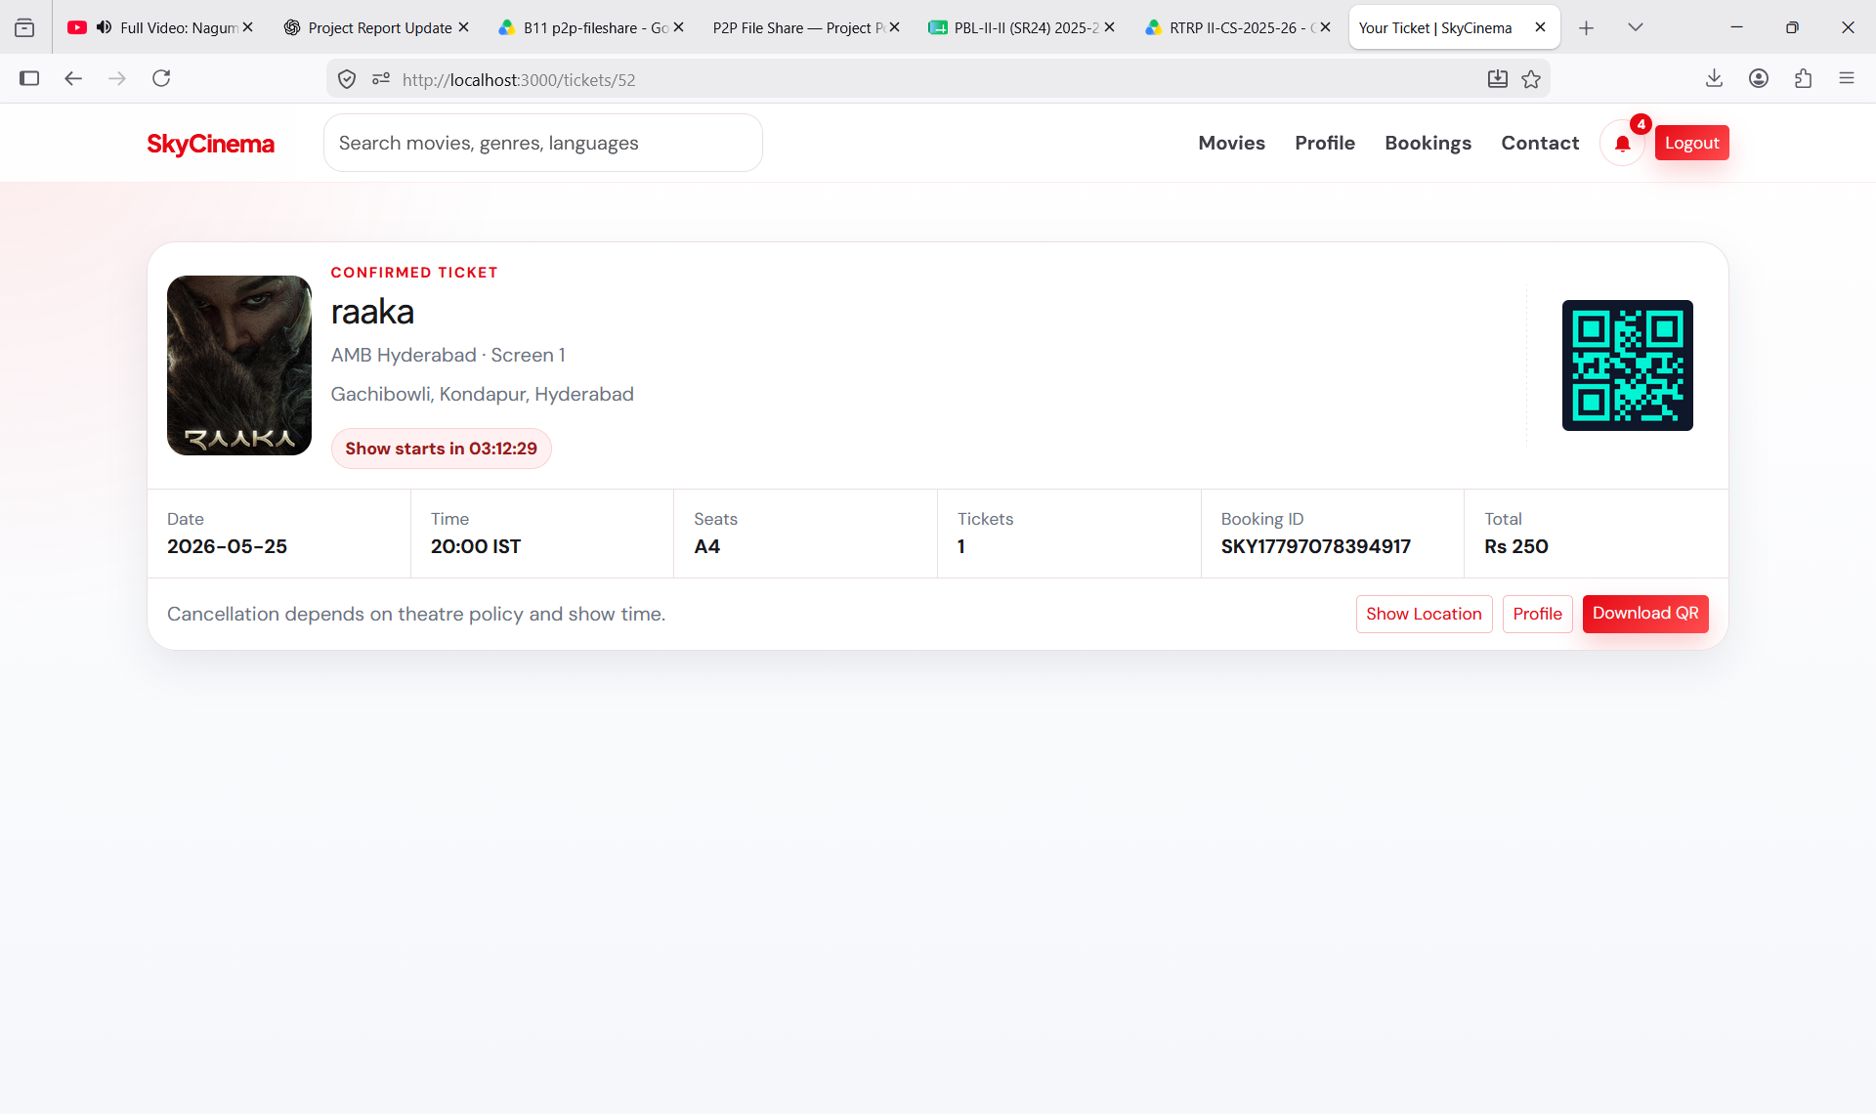
Figure 5.6: Ticket and QR Validation
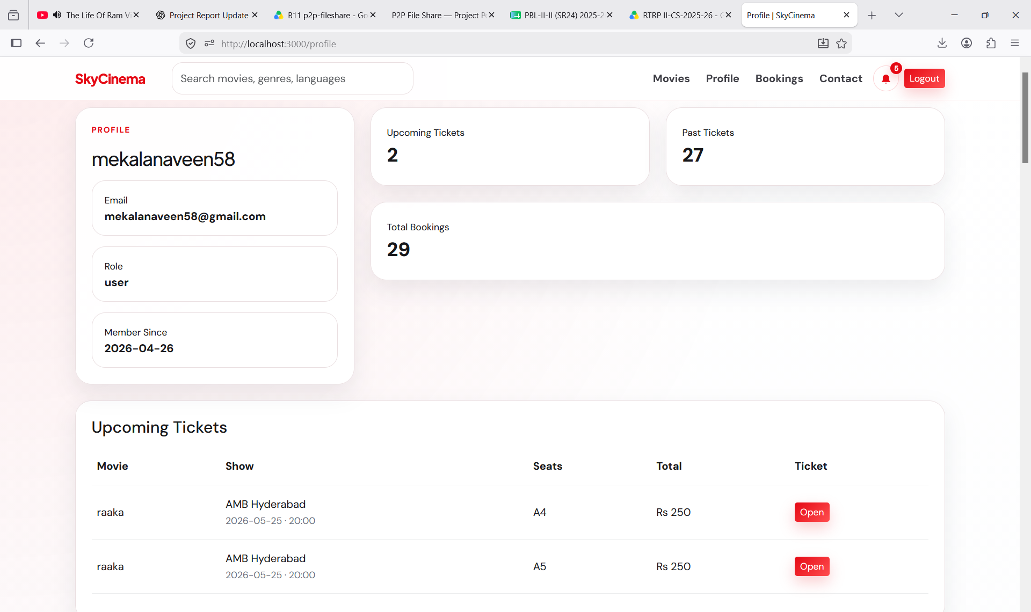
Figure 5.7: User Dashboard/Booking History
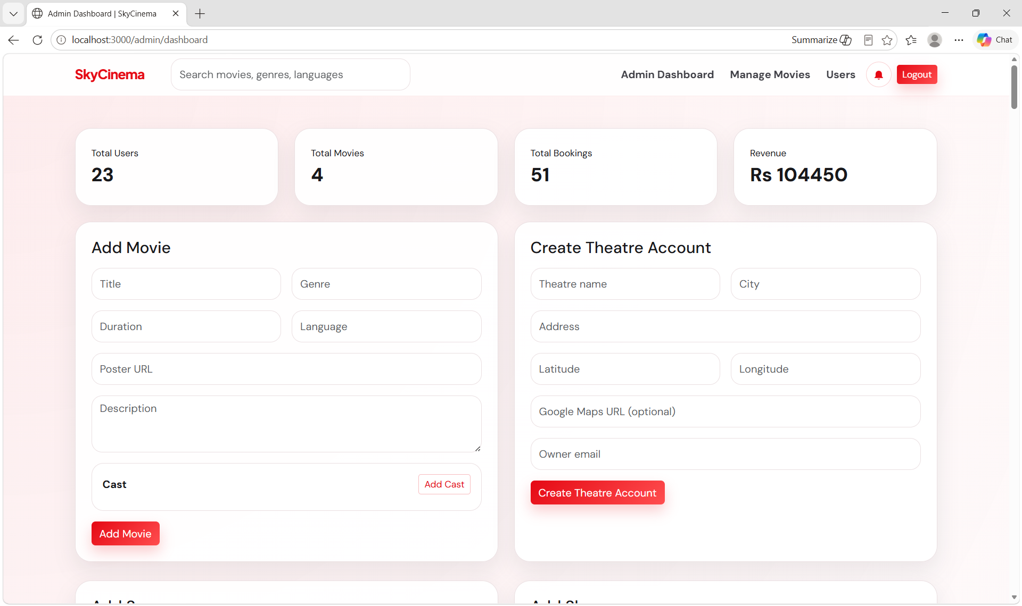
Figure 5.8: Admin Dashboard
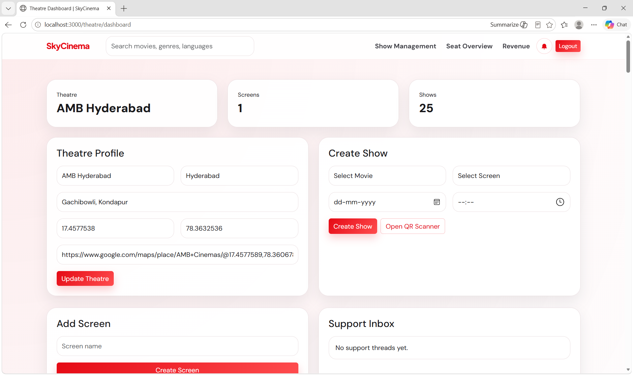
Figure 5.9: Theatre Owner Dashboard/Scanner
CHAPTER 6
CONCLUSION AND FUTURE ENHANCEMENT
CONCLUSION:
The Smart Movie Booking System successfully addresses the major challenge of real-time seat booking conflicts in online movie ticket platforms. By using Socket.io-based instant seat locking, the system prevents double booking and provides users with accurate seat availability during the booking process.
The project integrates user authentication, movie browsing, multi-theater support, show selection, live seat layout, booking history, QR ticket generation, admin monitoring, theatre owner validation, notifications, and MySQL database handling. This makes the application suitable for practical theatre and event booking environments.
The smart seat conflict handling mechanism is the key outcome of the project. It checks database status, manages temporary locks, rejects conflicting requests, broadcasts live updates, and releases abandoned locks automatically. This improves reliability, user experience, and operational efficiency.
The project also provides a foundation for future enhancements such as online payments, AI-based seat recommendations, dynamic pricing, and mobile application deployment.
FUTURE ENHANCEMENTS:
• Integrate a complete online payment gateway such as Razorpay with payment verification.
• Develop Android and iOS mobile applications for faster ticket booking.
• Add AI-based seat suggestions based on user preference, screen view, and group size.
• Introduce dynamic pricing based on demand, occupancy, day, and show time.
• Provide advanced analytics dashboards for theatre revenue, occupancy, and movie performance.
• Add push notifications for booking reminders, show alerts, offers, and cancellations.
• Support cancellation, refund, and rescheduling workflows.
• Integrate map-based theatre discovery and location-aware recommendations.
• Improve security with stronger audit logging and fraud detection.

REFERENCES
1. Node.js Official Documentation - https://nodejs.org/
2. Express.js Official Documentation - https://expressjs.com/
3. Socket.io Official Documentation - https://socket.io/
4. MySQL Documentation - https://dev.mysql.com/doc/
5. Bootstrap Documentation - https://getbootstrap.com/
6. QRCode Package Documentation - https://www.npmjs.com/package/qrcode
7. Nodemailer Documentation - https://nodemailer.com/
8. Razorpay Developer Documentation - https://razorpay.com/docs/
9. Software Engineering: A Practitioner's Approach, Roger S. Pressman.
10. Database System Concepts, Abraham Silberschatz, Henry F. Korth, S. Sudarshan.

APPENDIX AND SAMPLE CODE
A.1 DATASET / USER DATA DESCRIPTION
The database stores users with roles, movies with poster and detail information, theatres, screens, shows, seats, bookings, booking-seat mappings, QR ticket information, reviews, notifications, support conversations, and booking reminders.
Table | Purpose
users | Stores user profile, email, role, and account status.
movies | Stores movie title, genre, language, duration, description, and poster URL.
theatres | Stores theatre details and theatre owner relation.
screens | Stores screen names and total seats for each theatre.
shows | Stores movie, theatre, screen, date, and time combinations.
seats | Stores seat number, row, category, price, and status for each show.
bookings | Stores booking code, user, show, amount, status, and scan state.
booking_seats | Maps confirmed seats to bookings.
tickets | Stores generated QR ticket details.
notifications | Stores booking alerts and reminder messages.

A.2 SYSTEM MODULES / ARCHITECTURE
1. Authentication Module
OTP login verifies users and assigns role-based access.
2. Movie Module
Displays movie details, ratings, reviews, theatres, and shows.
3. Seat Locking Module
Maintains temporary locks and broadcasts updates using Socket.io.
4. Booking Module
Creates bookings, stores seat mappings, and updates seat status.
5. Ticket Module
Generates QR tickets and supports theatre validation.
6. Admin Module
Provides administrative monitoring and control.
7. Theatre Module
Supports show management, occupancy stats, and ticket scanning.
8. Notification Module
Sends and stores booking-related alerts.
A.3 TRAINING AND EXECUTION SETUP
Execution Setup
• Install project dependencies using npm install.
• Configure MySQL credentials in the .env file.
• Start the application using npm run dev or npm start.
• Open the application in a browser at the configured local URL.
• Use seeded movies, theatres, and show timings for testing.
Execution Flow
Start Server -> Connect Database -> Load Movies -> User Login -> Select Show -> Join Socket Room -> Lock Seats -> Confirm Booking -> Generate Ticket -> Validate QR Ticket
A.4 DEPLOYMENT DETAILS
The application can be deployed on a Node.js compatible hosting environment with a MySQL database. Environment variables should be configured securely for database credentials, JWT secret, email service credentials, and application URL.
Deployment Features
• Server-side rendered movie booking pages.
• Persistent MySQL data storage.
• Socket.io real-time communication.
• Email-based OTP verification.
• QR ticket generation and validation.
• Role-based dashboards for admin and theatre owners.
A.5 RESULTS
The completed project demonstrates successful movie booking, real-time seat conflict prevention, QR ticket generation, database persistence, and dashboard-based monitoring.
A.6 BENEFITS OF THE SYSTEM
• Prevents double booking through real-time seat locks.
• Improves booking speed and user confidence.
• Supports multiple theatres and show timings.
• Reduces manual ticket validation work through QR scanning.
• Provides admin and theatre dashboards for operational control.
• Maintains structured booking history and notification records.

